CMPE-258 Deep Learning

Assignment 0

Submitted By

Vijaylaxmi Nagurkar

013848406

Github Repository: <https://github.com/vijaylaxmid/cmpe258-deeplearning>

Github Repository and Public Repository

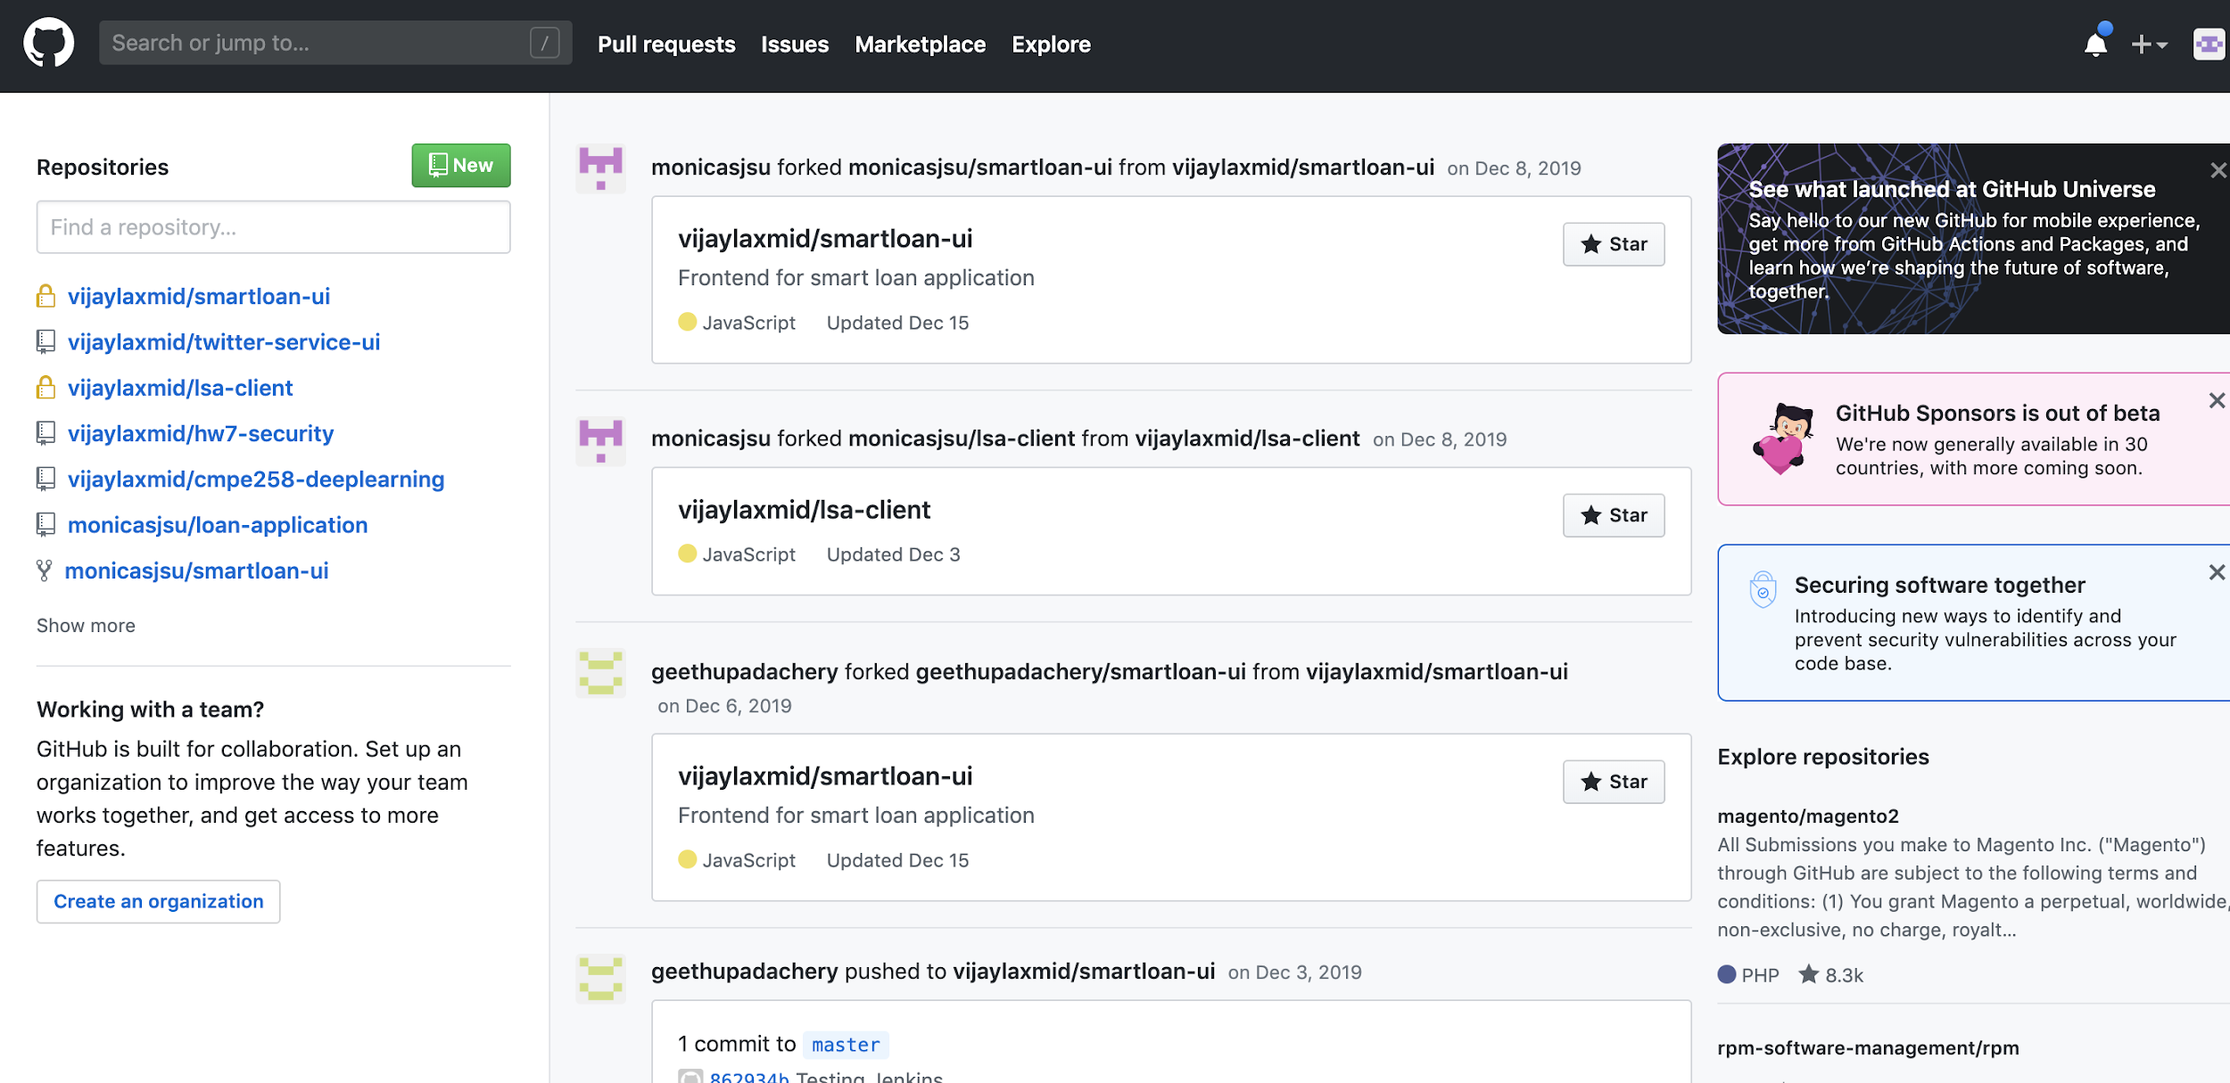

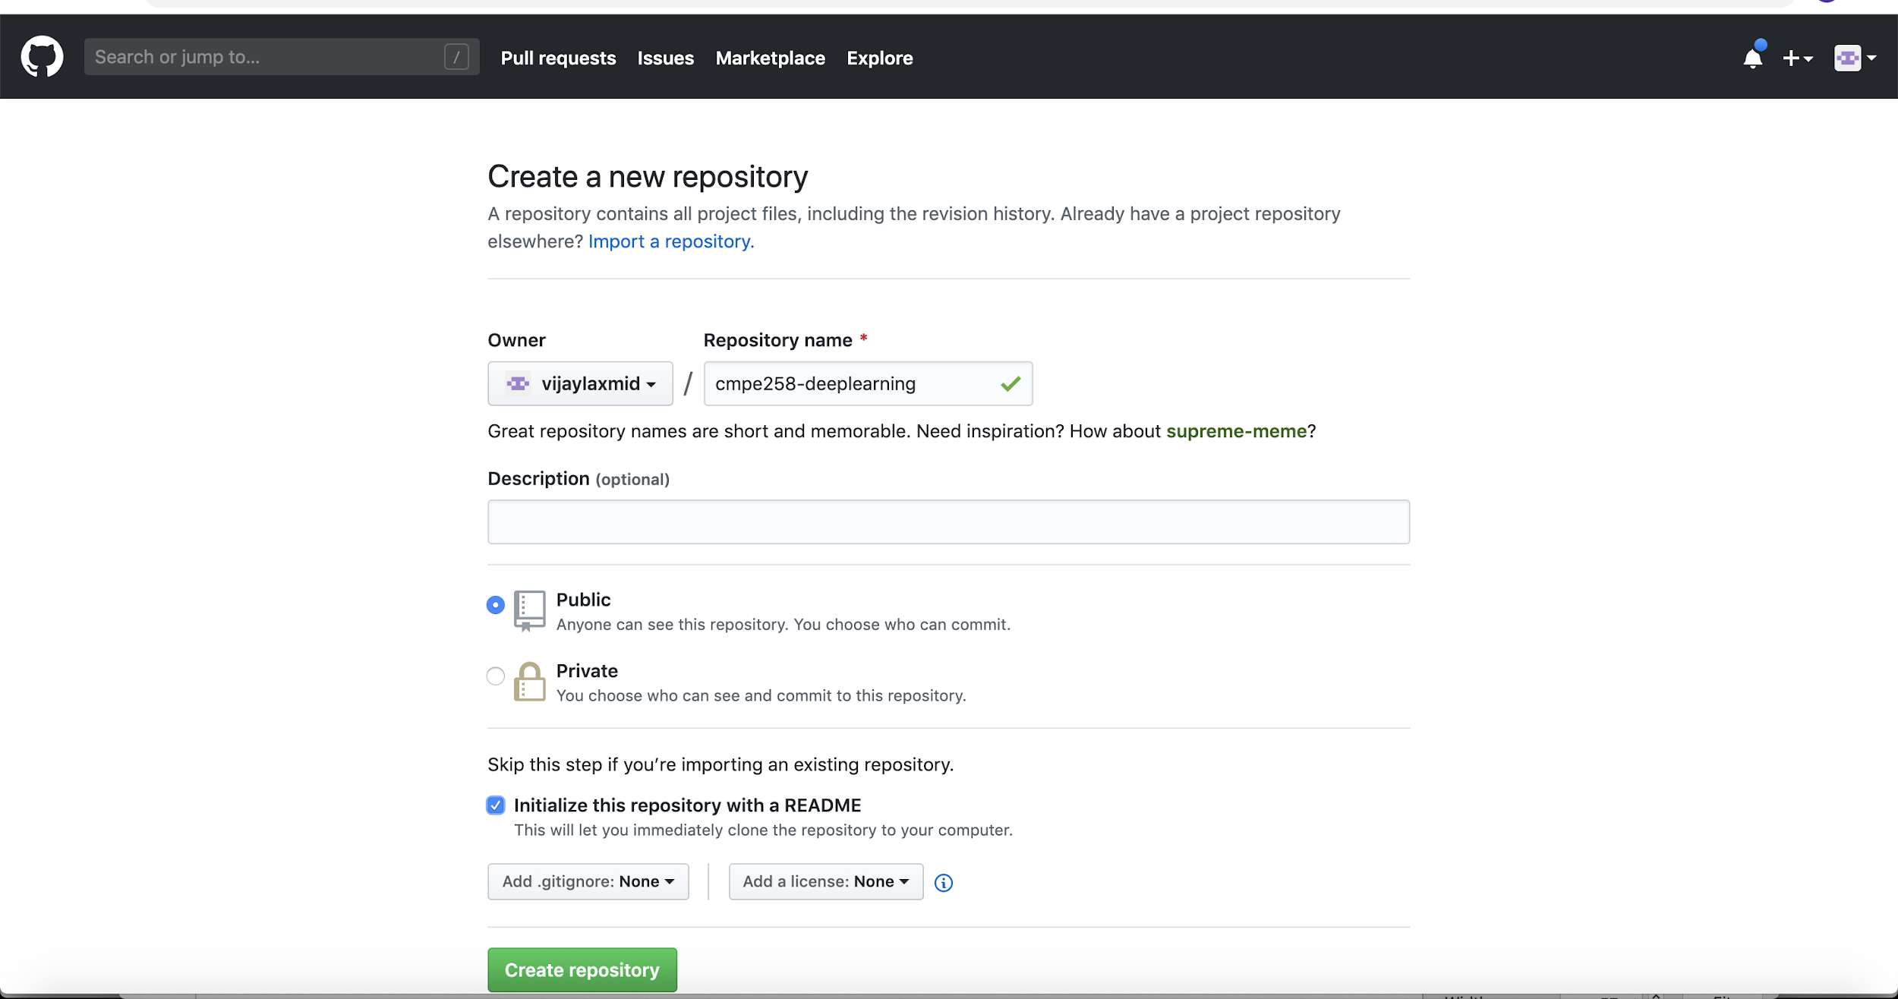

Github tab under Colab Welcome Page

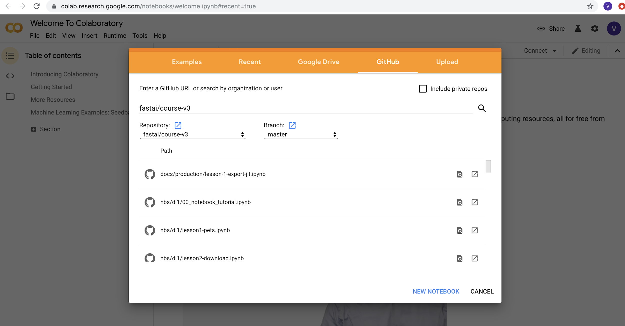

Change Runtime Type to use GPU

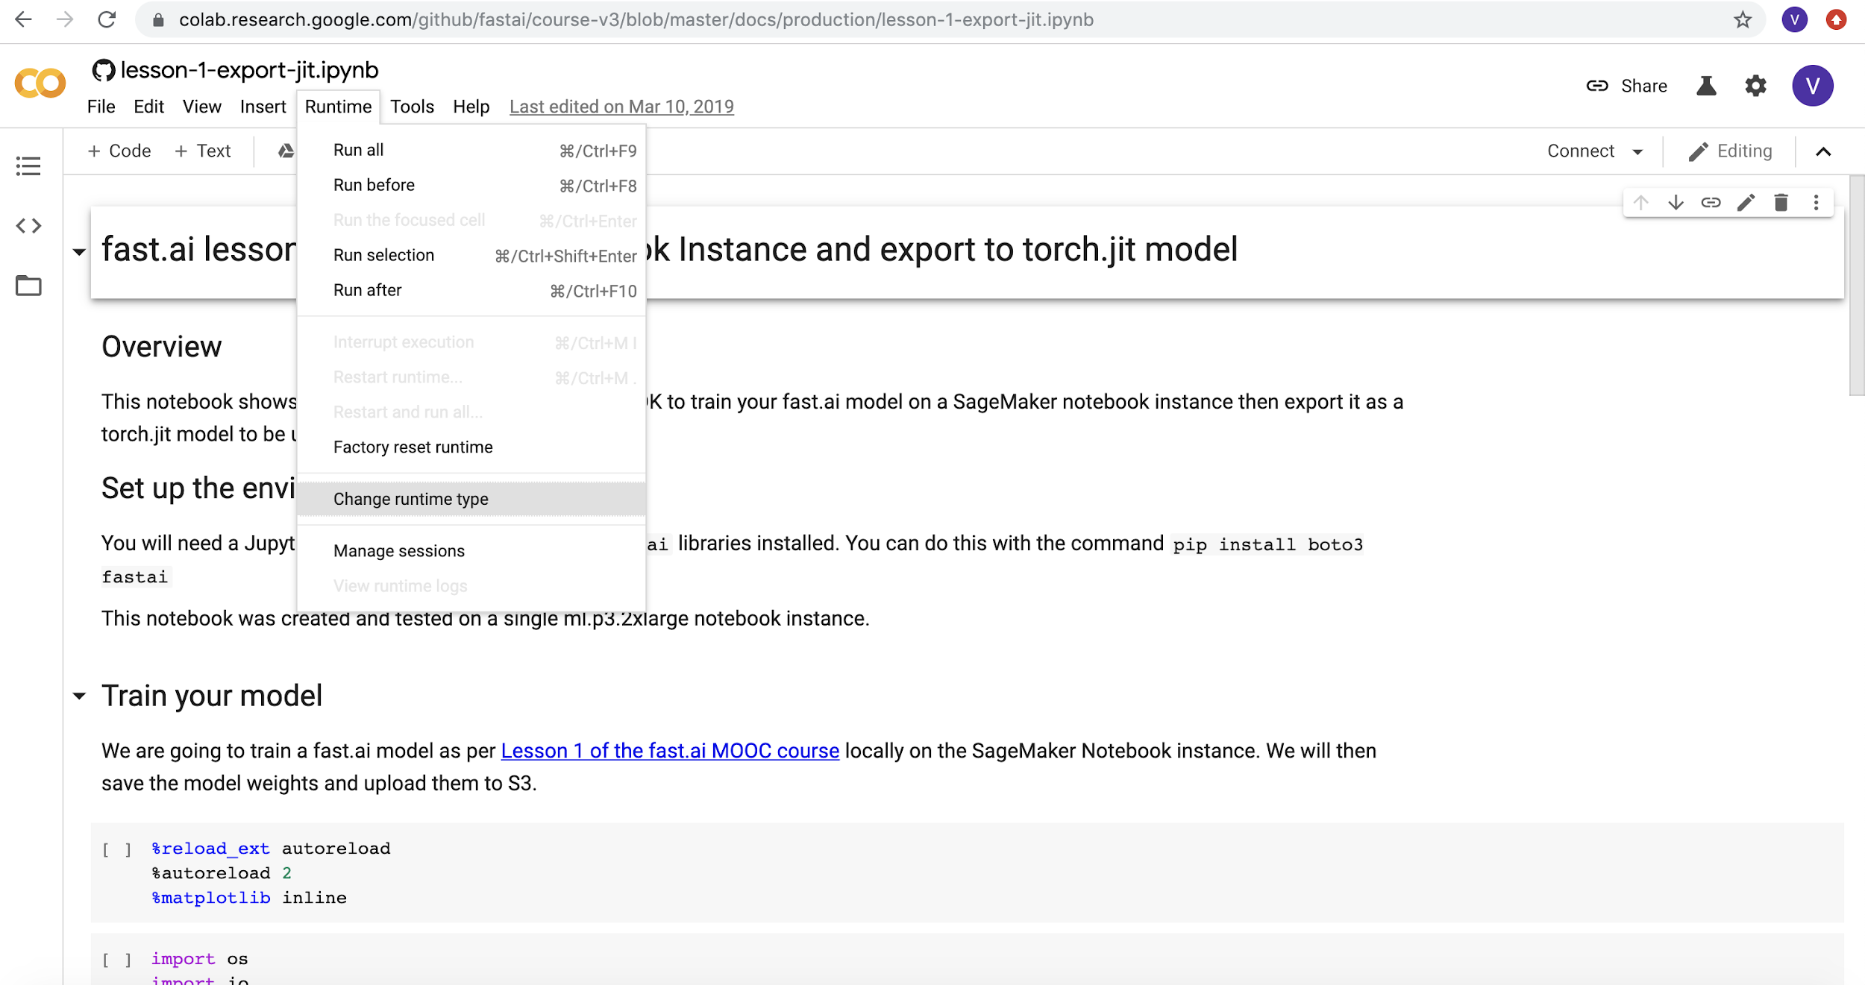

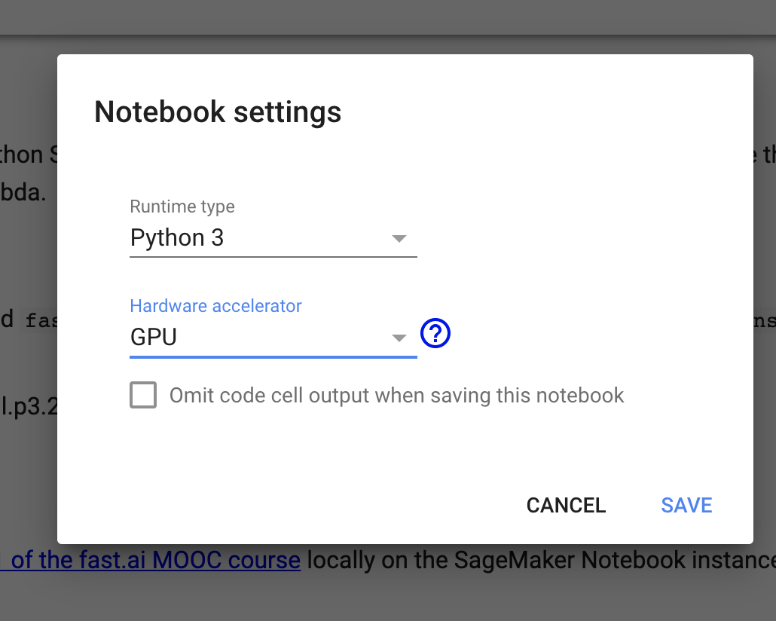

Configuring notebook instance

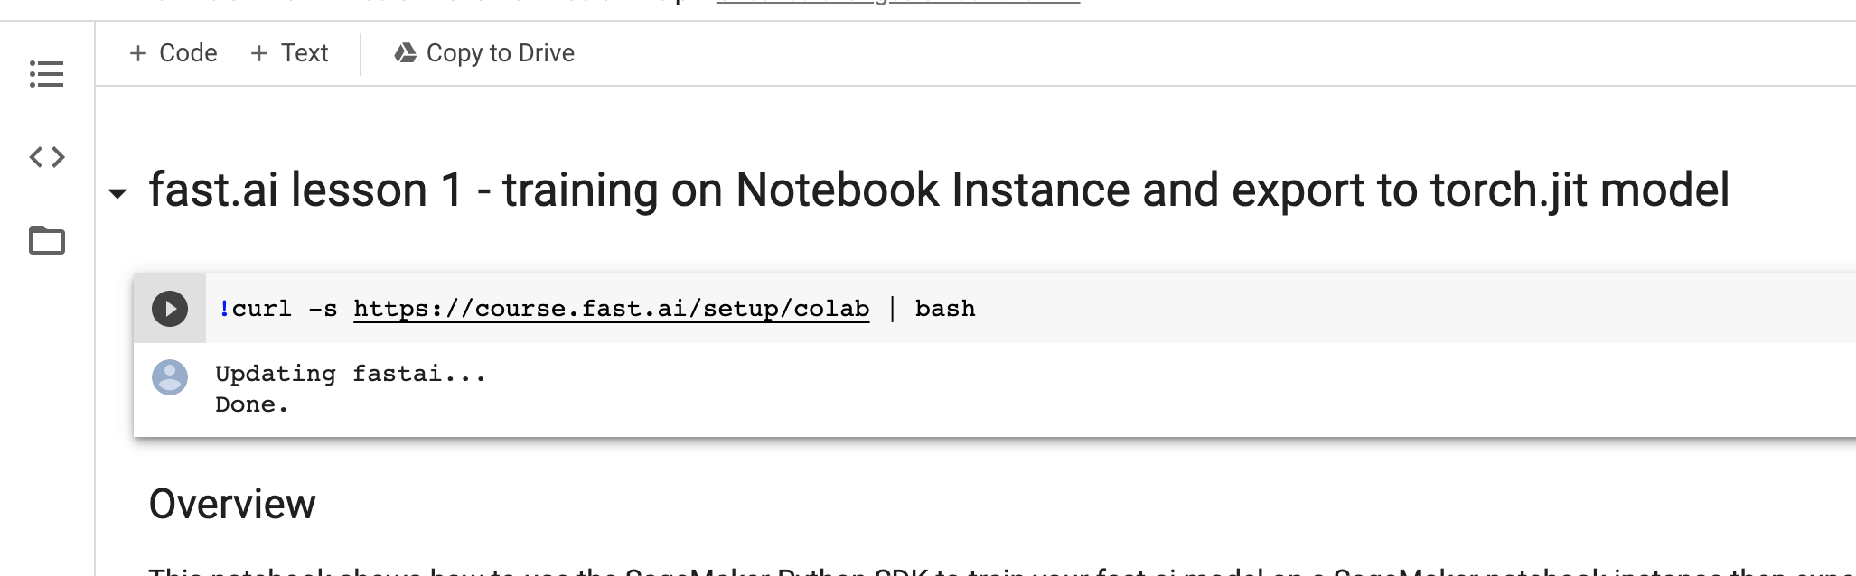

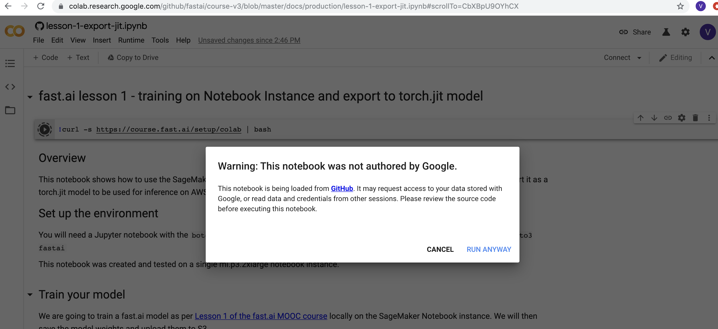

Saving the notebook

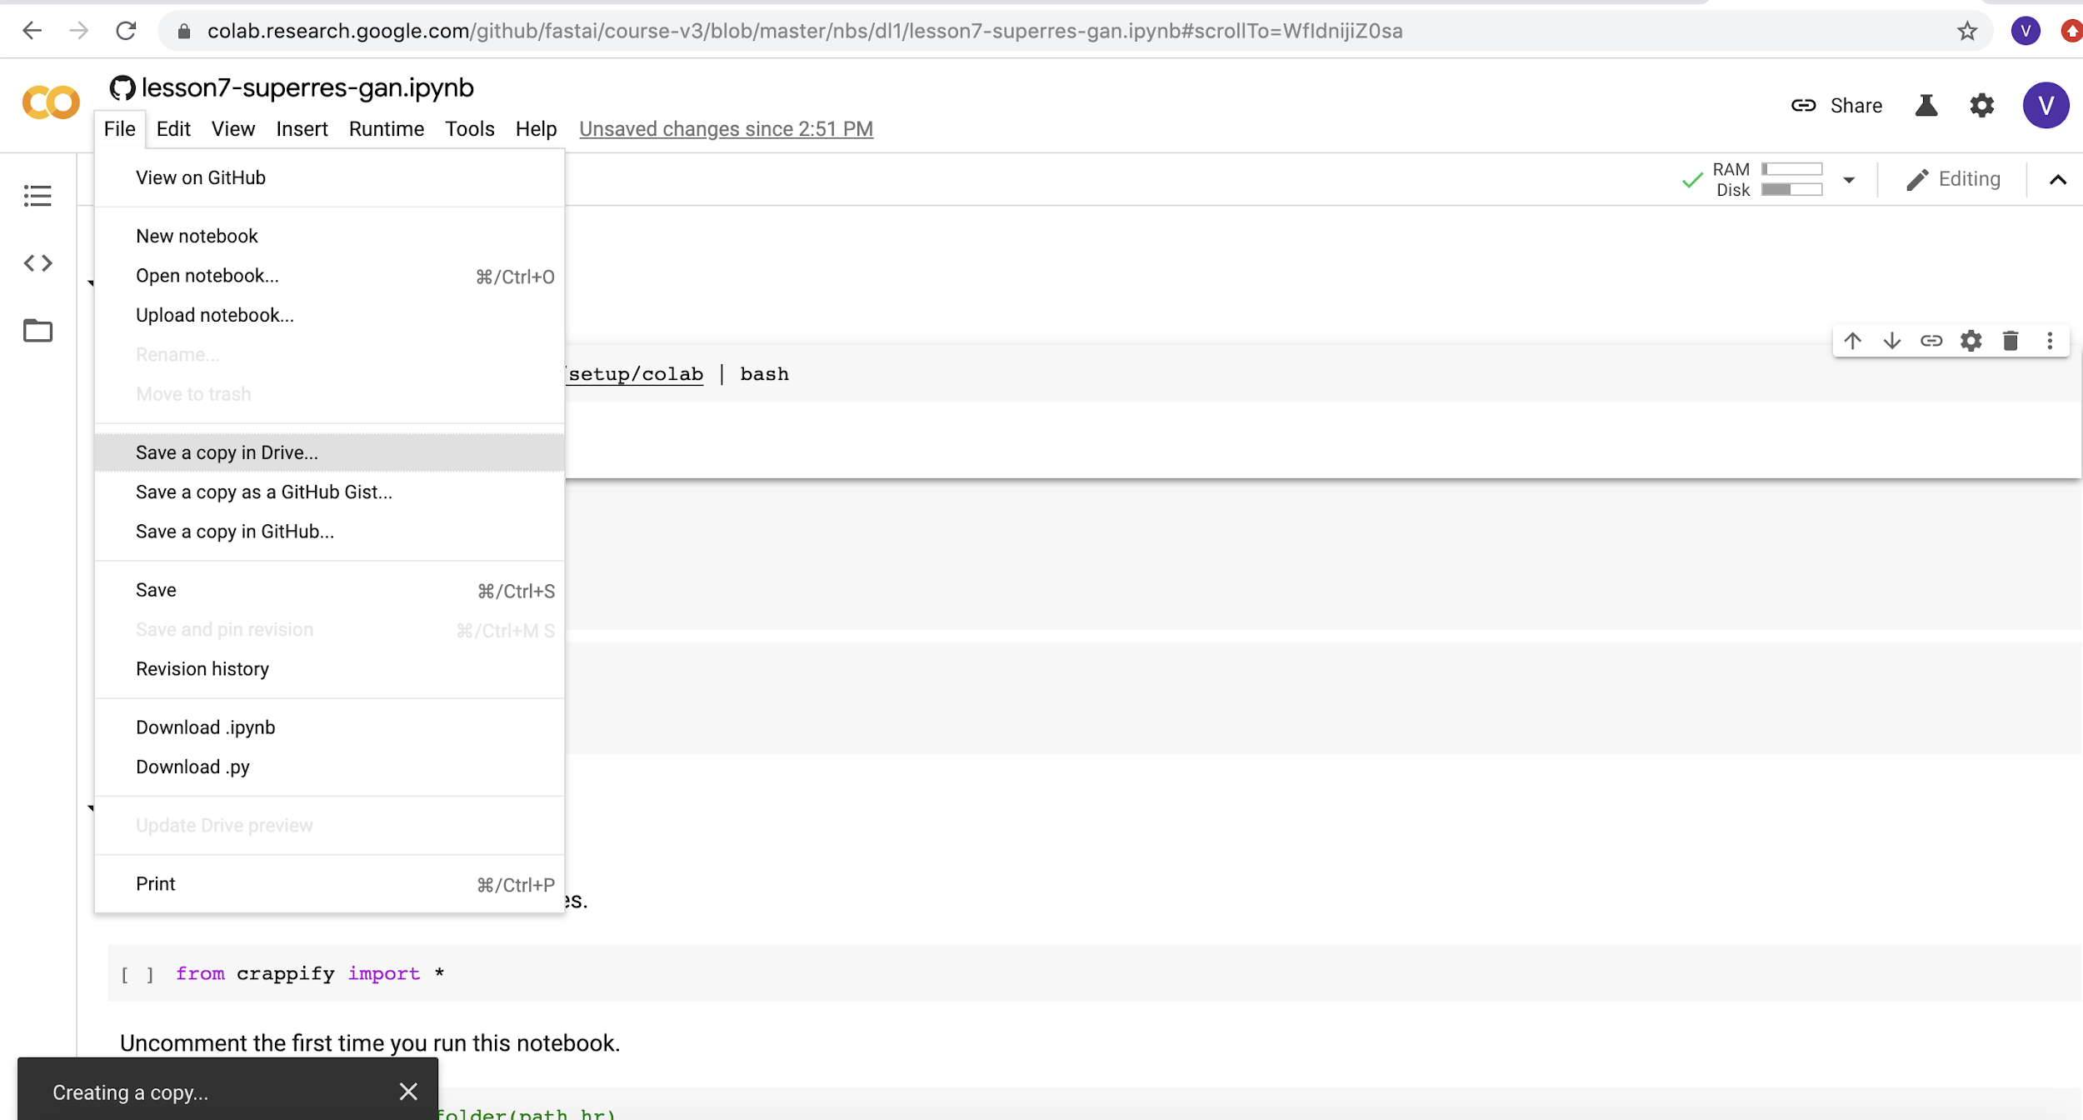

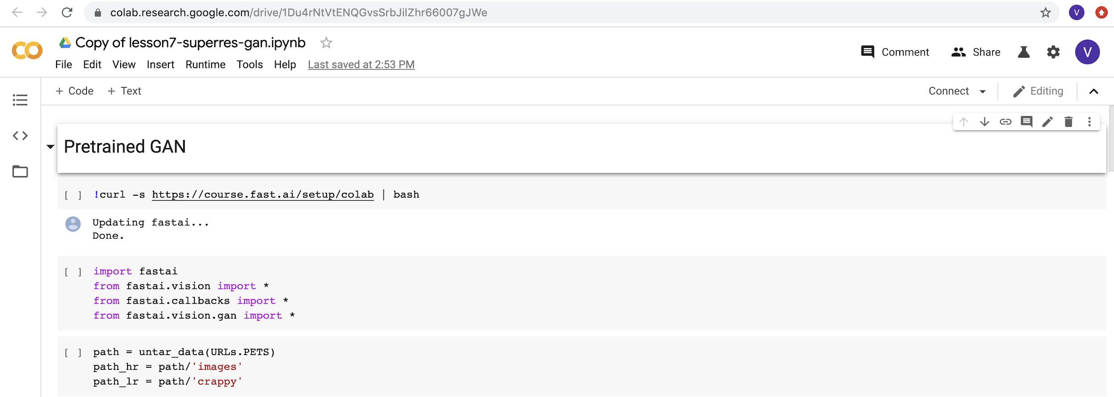

The folder “Colab Notebooks” in My Drive

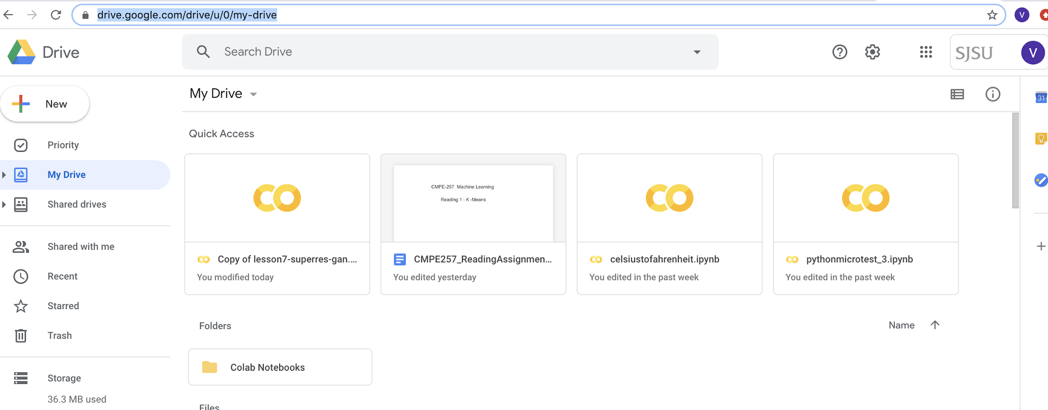

1. Published the test notebook to github

Github link:

<https://github.com/vijaylaxmid/cmpe258-deeplearning>

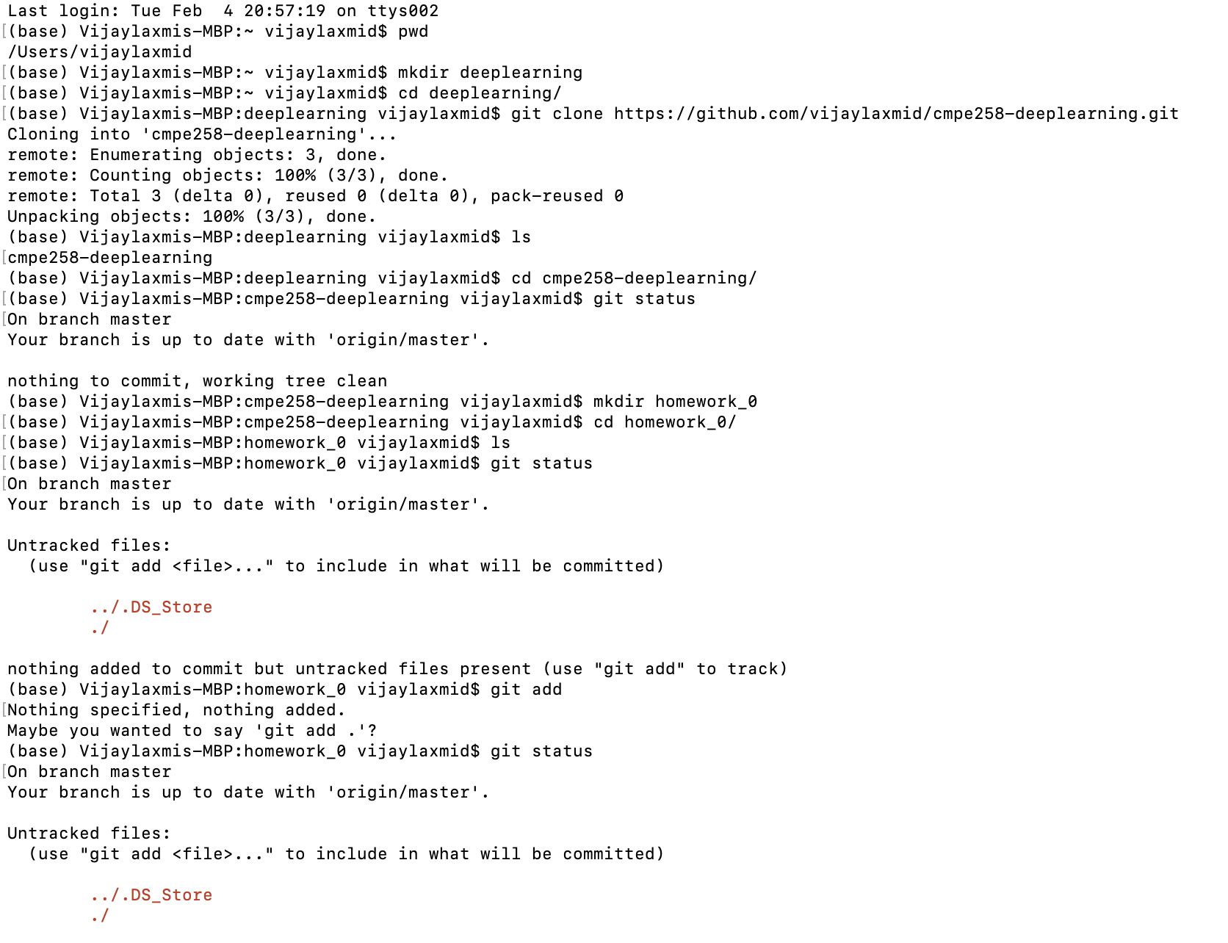

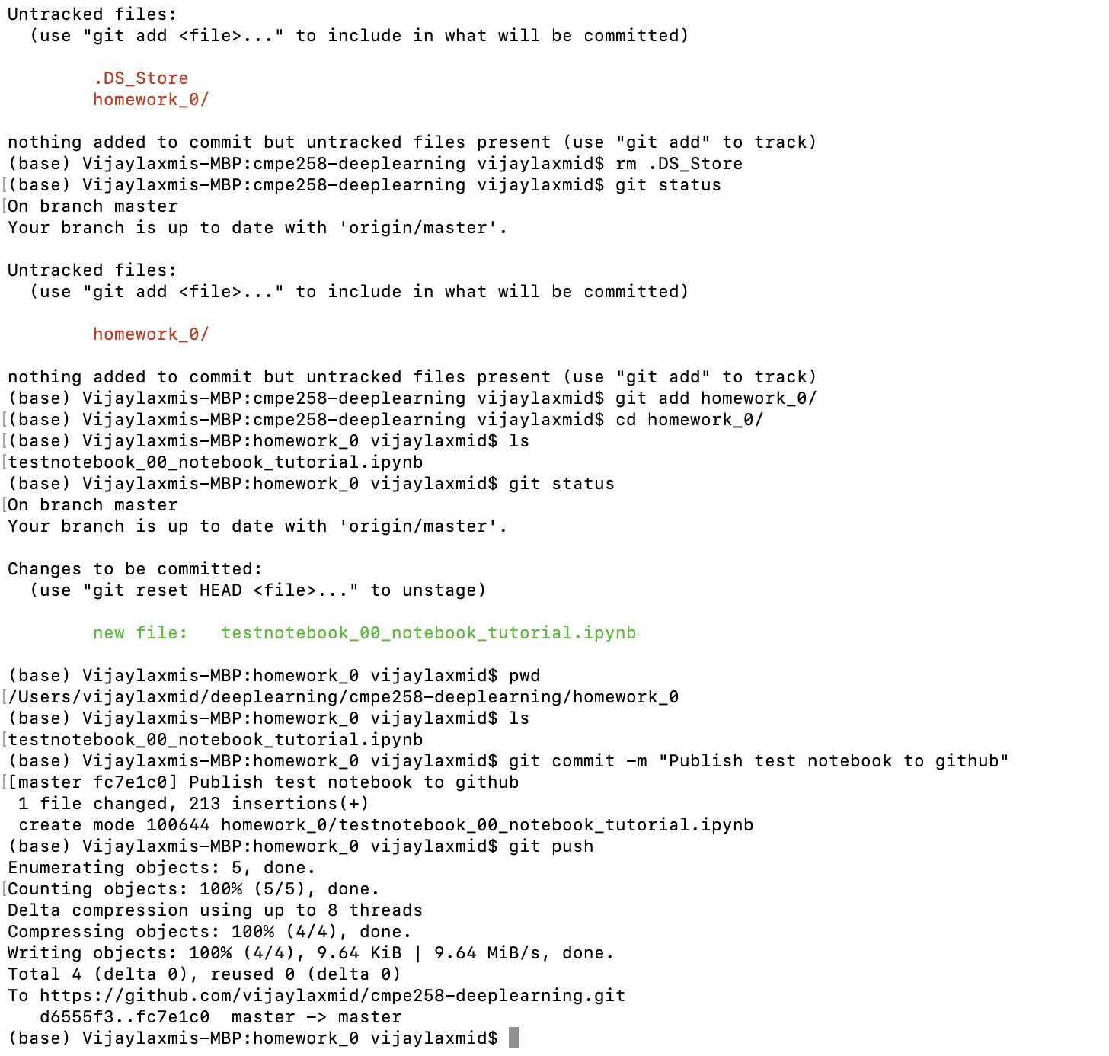

1. Published the following notebook to github

<https://github.com/ageron/handson-ml2/blob/master/01_the_machine_learning_landscape.ipynb>

[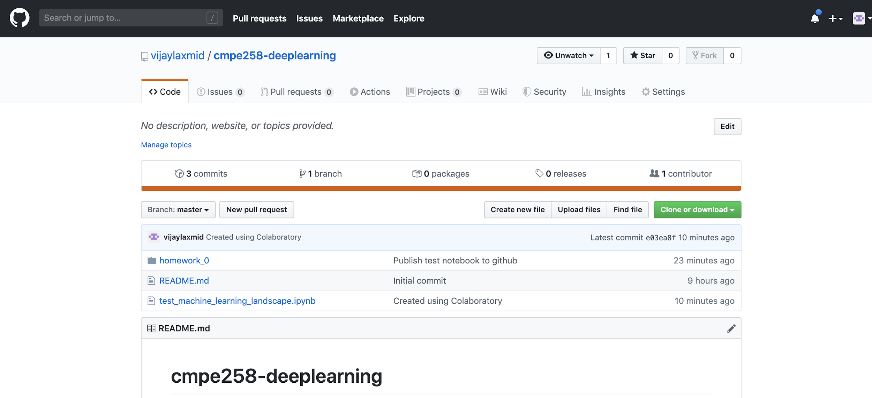](https://github.com/ageron/handson-ml2/blob/master/01_the_machine_learning_landscape.ipynb)

1. Practiced the following collab and published to github

<https://colab.research.google.com/github/jakevdp/PythonDataScienceHandbook/blob/master/notebooks/02.02-The-Basics-Of-NumPy-Arrays.ipynb>

